Project Design Phase
Solution Architecture

Date | 15 February 2025
Team ID | LTVIP2026TMIDS77573
Project Name | Explore with AI: Custom Itineraries for Your Next Journey
Maximum Marks | 4 Marks

Solution Architecture:

Solution architecture for TravelGuideAI defines how the system converts user travel needs into intelligent, AI-generated itineraries. It connects user requirements, application logic, and generative AI services into a smooth, scalable system.
Goals of the TravelGuideAI Solution Architecture
● Deliver an AI-powered travel planning solution that generates personalized itineraries based on destination, days, and nights.
● Clearly define system structure and components (UI, backend, AI model, and APIs) so stakeholders understand how the system works.
● Outline features and development phases such as itinerary generation, user input handling, and result presentation.
● Specify technical requirements for deployment, API integration, and data handling.
● Ensure scalability and reliability so multiple users can generate itineraries simultaneously.
● Provide a blueprint for development and maintenance, enabling future upgrades like hotel suggestions, maps, and budget planning.

Solution Architecture Diagram:

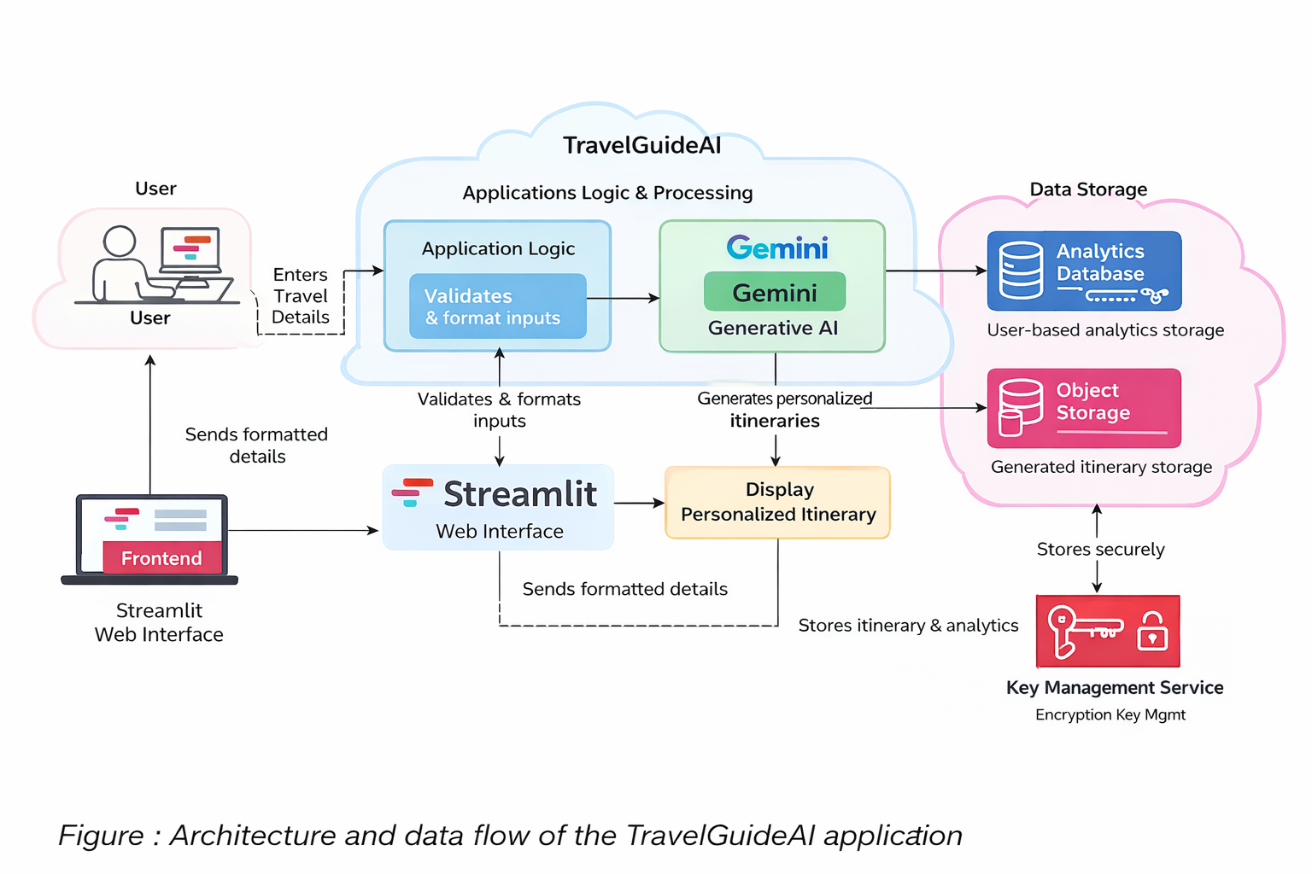

Reference: https://aws.amazon.com/blogs/industries/voice-applications-in-clinical-research-powered-by-ai-on-aws-part-1-architecture-and-design-considerations/

